I used Chrome Developer Tools to inspect the HTTP request and response when visiting [**https://www.youtube.com**](https://www.youtube.com).

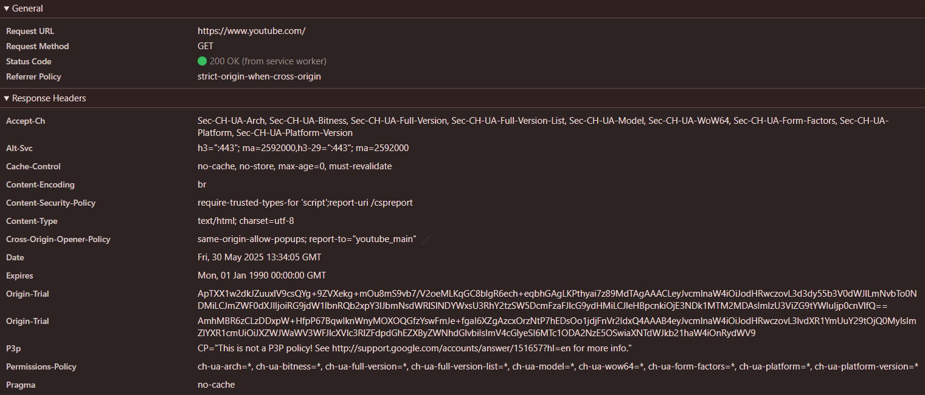

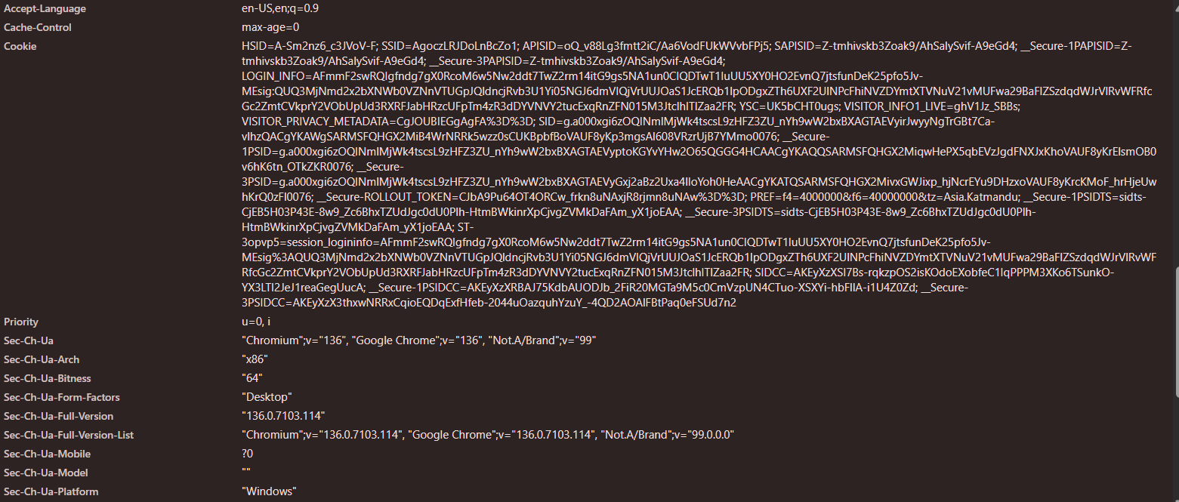

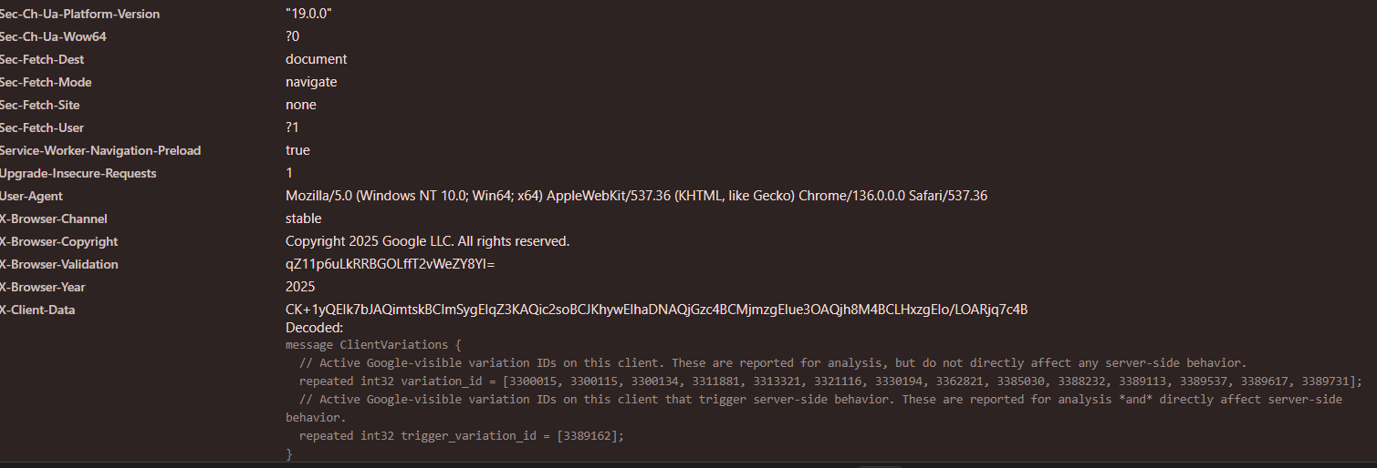

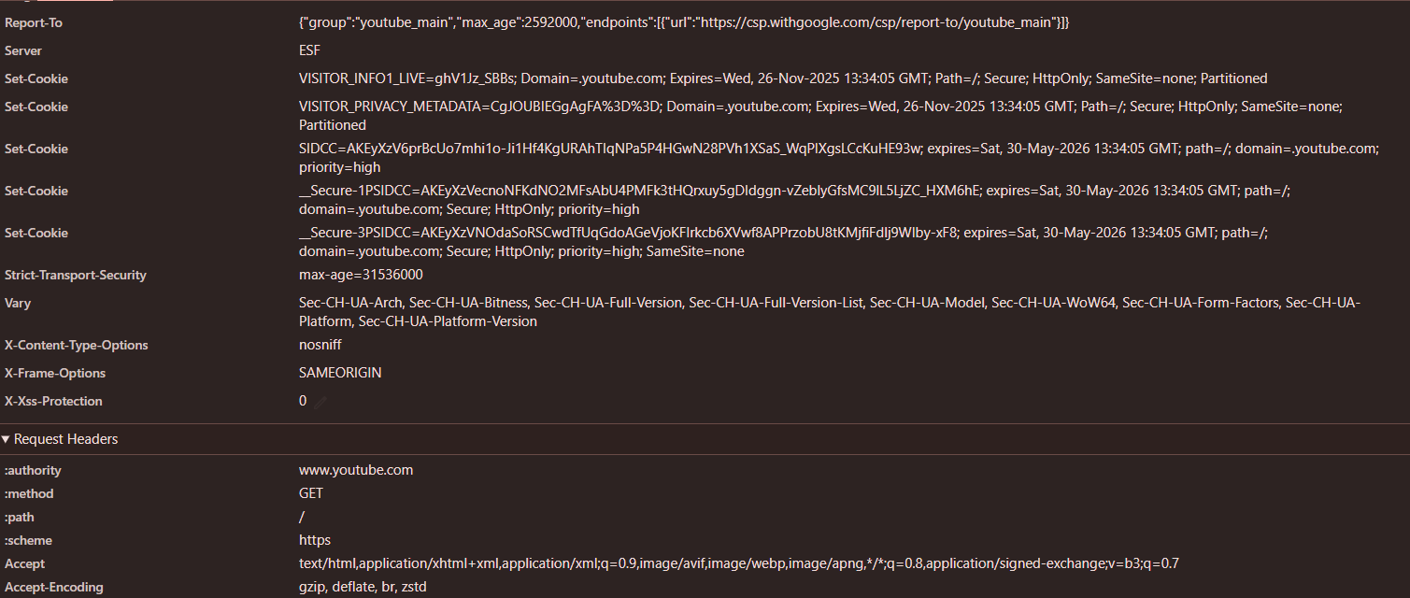

## **General Information**

This section gives a quick overview of the main request made by your browser:

* **Request URL:** https://www.youtube.com/  
  → This is the address your browser requested.
* **Request Method:** GET  
  → This tells the server to send back the page data.
* **Status Code:** 200 OK  
  → The server successfully returned the webpage.
* **Referrer Policy:** strict-origin-when-cross-origin  
  → This controls what referrer information is sent when navigating to another page.

**Response Headers**

These are sent **from the server** back to your browser:

* **Content-Type:** text/html; charset=utf-8  
  → The returned file is an HTML document.
* **Cache-Control:** no-cache, no-store, must-revalidate  
  → Tells the browser not to cache the page.
* **Content-Security-Policy:** require-trusted-types-for 'script'  
  → Adds protection against XSS (Cross-Site Scripting).
* **Set-Cookie:**  
  → The server sets cookies like VISITOR_INFO1_LIVE, SIDCC, and others for session management and user tracking.
* **Strict-Transport-Security:**  
  → Forces the browser to always use HTTPS for security.
* **X-Frame-Options:** SAMEORIGIN  
  → Prevents the page from being loaded in a frame on another site.
* **Date:**  
  → Shows when the response was sent by the server.

### Request Headers

These are sent **from your browser to the server**:

* **User-Agent:**  
  → Tells the server what browser and operating system you are using (e.g., Chrome 136 on Windows 10).
* **Accept:**  
  → Lists the content types your browser can process (HTML, images, etc.).
* **Accept-Encoding:**  
  → Tells the server your browser supports compressed formats like gzip or br.
* **Accept-Language:**  
  → Indicates your language preferences (e.g., en-US for English).

### Cookies

These are small pieces of data sent along with the request, which help maintain session state and user identity:

Examples from your screenshot:

* HSID, SSID, APISID, SAPISID: For login and security.
* SIDCC, 1PSID, 3PSID: For tracking sessions and analytics.
* VISITOR_INFO1_LIVE: Likely stores YouTube user preferences or settings.